EmbedUR NETWORKING ASSIGNMENT-5
MODULE 7&8

G ADITHYA PRASAD

QUE 1: Try Test-Connection and nslookup commands for below websites:
- www.google.com
- www.facebook.com
- www.amazon.com
- www.github.com
- www.cisco.com

SOLUTION:
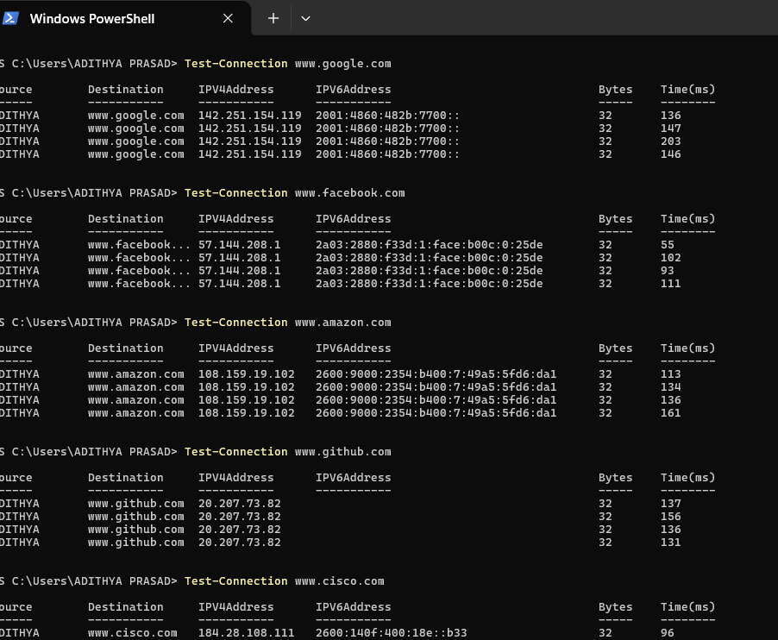

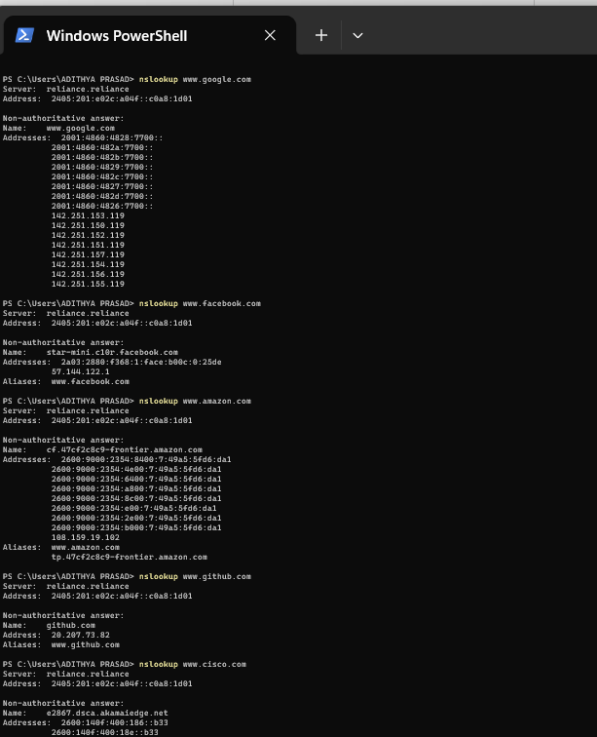

QUE 2: Use Wireshark to capture and analyze DNS, TCP, UDP traffic and study packet header, packet flow, options and flags.

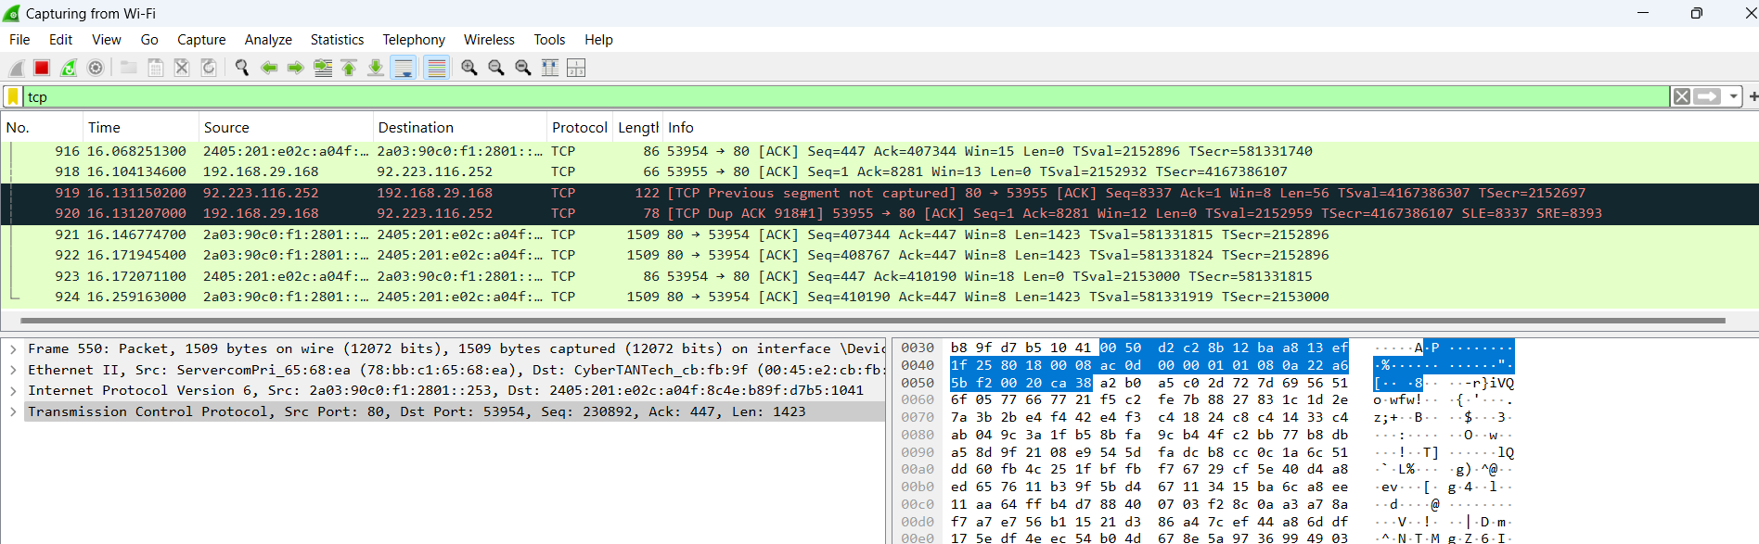

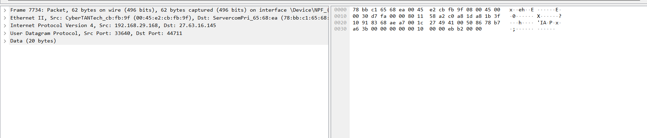

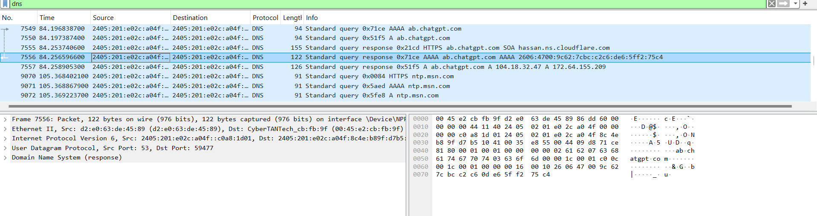

QUE 3: Explore traceroute / tracert for different websites (e.g., google.com) and analyze the parameters in the output. Also explore different options for the traceroute command.
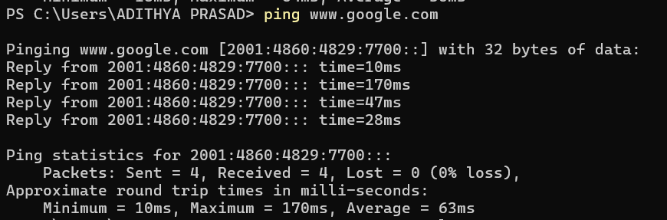

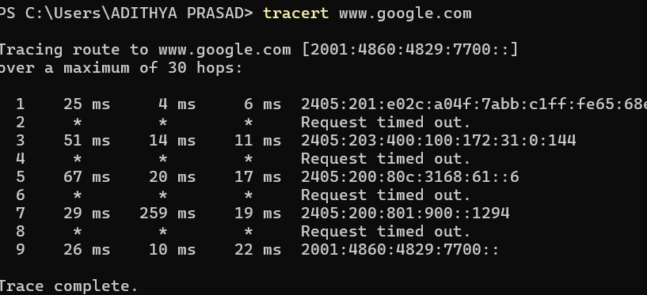

Que 4: Using Cisco Packet Tracer, perform the following:
- Set up trunk ports between two switches.
- Create multiple VLANs and verify ping between same VLANs across switches.
- Change the native VLAN on the trunk port.
- Create a VLAN mismatch, observe the issue, and troubleshoot it.
- Configure a Management VLAN, assign an IP address to the switch for remote access.
- Test SSH or Telnet access to the switch.

SOLUTION:

FIRSTLY CREATE THE TOPOLOGY and do router config (no shutdown):

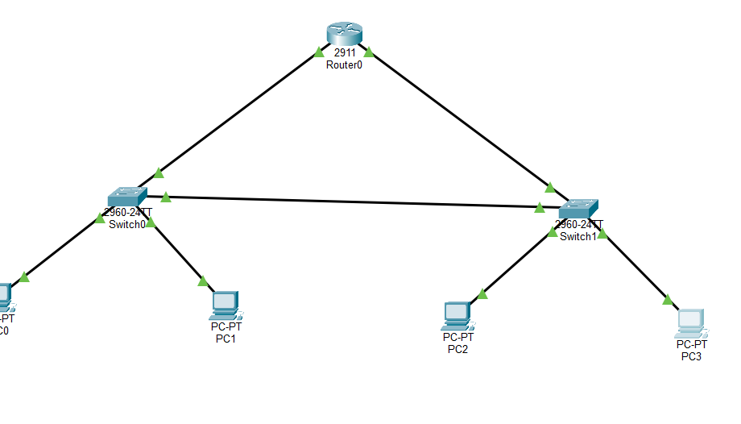

STEP 2: basic switch cofig (hostname S1 on switch0, hostname S2 on switch1):

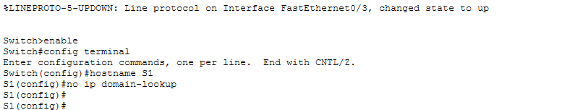

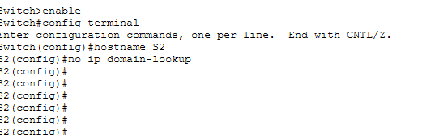

STEP 3: Create VLANs (S1 and S2)
For creating VLAN’S,
vlan 10
name VLAN10
vlan 20
name VLAN20
vlan 99
name MGMT
exit
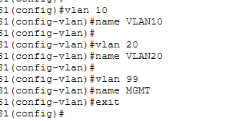

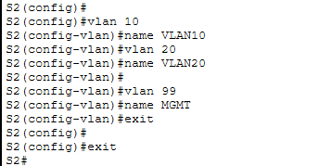

STEP 4: Assign Access Ports to VLANs
IN S1, CLI
Put Fa0/1 into VLAN 10 (PC0 port)
interface fa0/1
switchport mode access
switchport access vlan 10
exit

Put Fa0/2 into VLAN 20 (PC1 port)
interface fa0/2
switchport mode access
switchport access vlan 20
exit
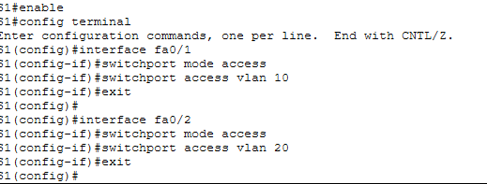

In S2,CLI
Fa0/1 → VLAN 10 (PC2)
interface fa0/1
switchport mode access
switchport access vlan 10
exit
Fa0/2 → VLAN 20 (PC3)
interface fa0/2
switchport mode access
switchport access vlan 20
exit
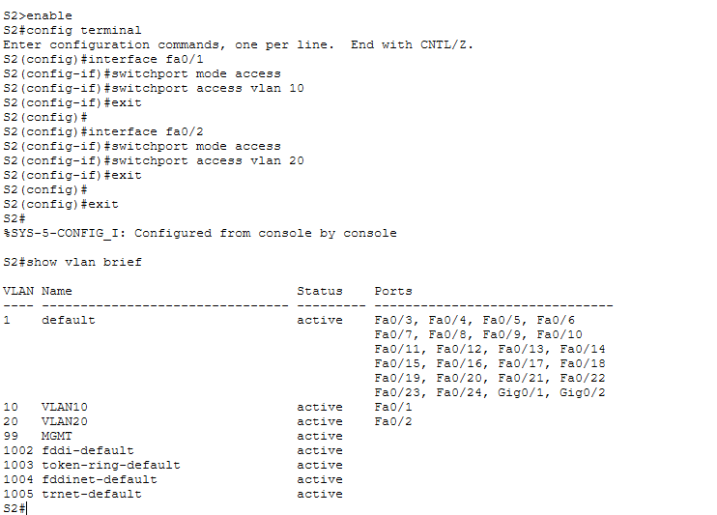

Step 5: CONFIGURING TRUNKS
FIRSTLY, Trunk Between S1 and S2, (b/w two switches we used fa0/24)

On S1,
enable
configure terminal
interface fa0/24
switchport mode trunk
switchport trunk native vlan 99
exit
On S2 also repeat the same.
SECONDLY, Trunk from S1 to Router
On S1:
interface fa0/23
switchport mode trunk
exit
THIRDLY, Trunk from S2 to router
interface fa0/23
switchport mode trunk
exit

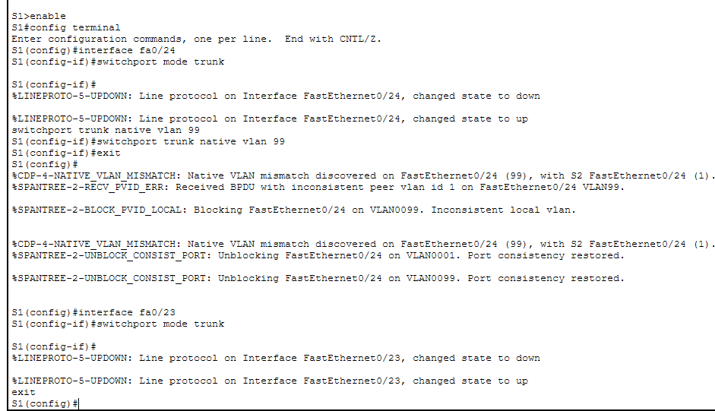

On S2,
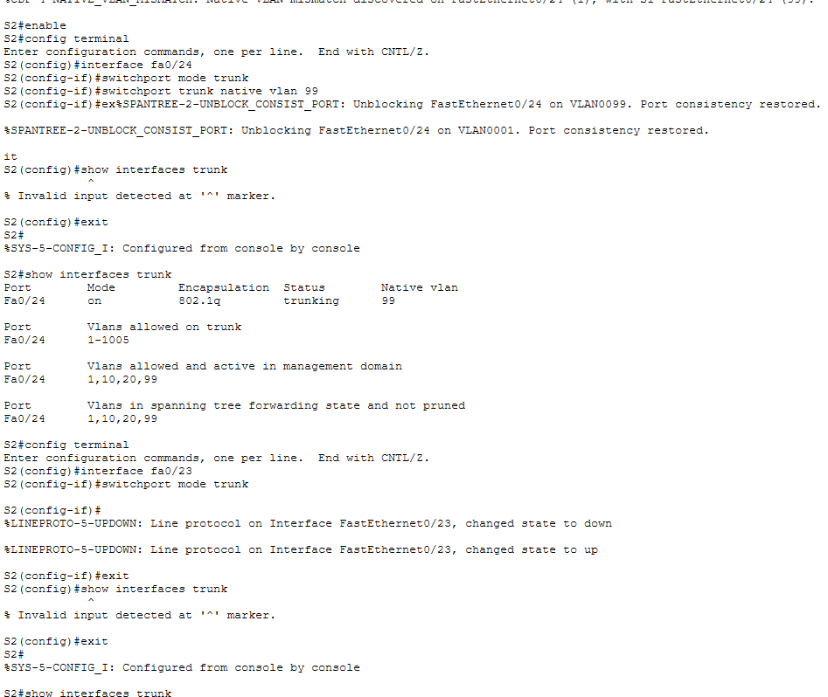
STEP 6: ROUTER CONFIGURATION(R1)

Configure subinterfaces on G0/0 (link to S1)
Each subinterface = one VLAN gateway.
Firstly,
interface g0/0.10
encapsulation dot1Q 10
ip address 192.168.10.1 255.255.255.0
exit
interface g0/0.20
encapsulation dot1Q 20
ip address 192.168.20.1 255.255.255.0
exit
interface g0/0.99
encapsulation dot1Q 99 native
ip address 192.168.99.1 255.255.255.0
exit
What this means
- .10 handles VLAN 10 traffic
- .20 handles VLAN 20 traffic
- .99 handles native/management VLAN
- dot1Q tells router to understand VLAN tags

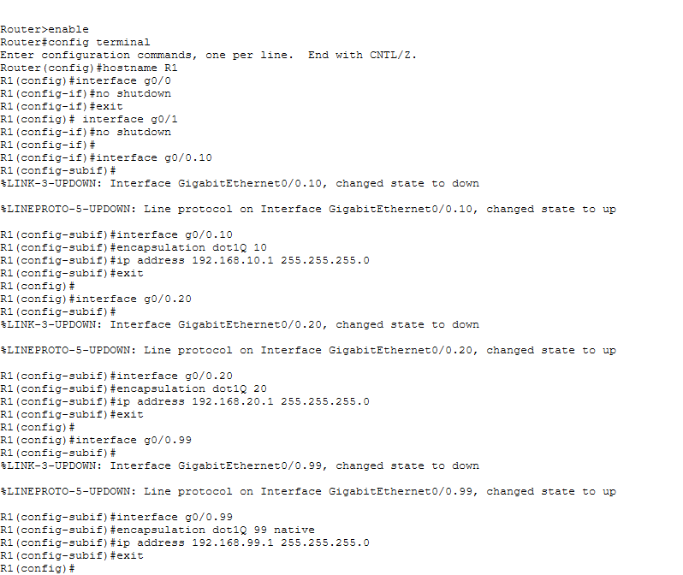
Configure subinterfaces on G0/1 (link to S2)
This allows S2 side VLAN traffic to reach router too.
interface g0/1.10
encapsulation dot1Q 10
ip address 192.168.10.254 255.255.255.0
exit
interface g0/1.20
encapsulation dot1Q 20
ip address 192.168.20.254 255.255.255.0
exit
interface g0/1.99
encapsulation dot1Q 99 native
ip address 192.168.99.254 255.255.255.0
exit
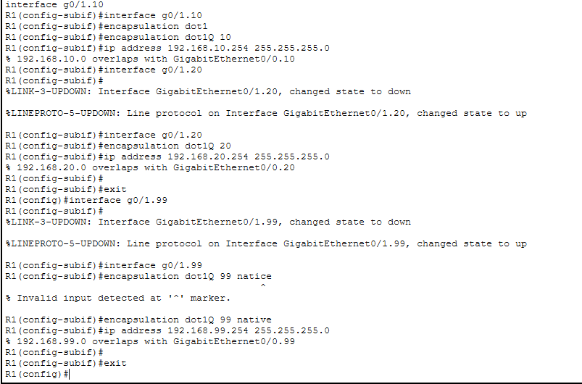

HERE WE DESIGN 2 IPS FOR THE SAME VLAN.

You connected router to both switches.
So:
- VLAN 10 gateway via S1 side → 192.168.10.1
- VLAN 10 gateway via S2 side → 192.168.10.254
Either path can route traffic (good lab design).

STEP 7 : Assign IP to PCs

PC | VLAN | IP Address | Subnet Mask | Default Gateway
PC0 (S1 Fa0/1) | 10 | 192.168.10.2 | 255.255.255.0 | 192.168.10.1
PC2 (S2 Fa0/1) | 10 | 192.168.10.3 | 255.255.255.0 | 192.168.10.1
PC1 (S1 Fa0/2) | 20 | 192.168.20.2 | 255.255.255.0 | 192.168.20.1
PC3 (S2 Fa0/2) | 20 | 192.168.20.3 | 255.255.255.0 | 192.168.20.1
STEP 8: Test Same VLAN Communication (Switching test)

FIRSTLY, From PC0 (VLAN 10)
ping 192.168.10.3
(PC0 → PC2 across switches)
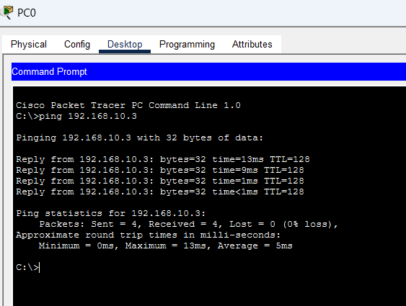

From PC1 (VLAN 20)
ping 192.168.20.3
(PC1 → PC3 across switches)
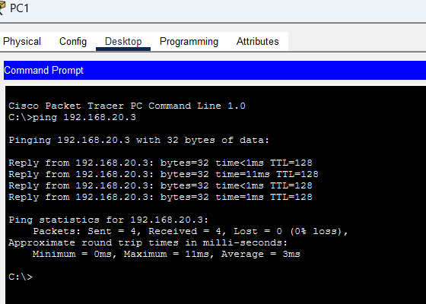
STEP 9: Inter-VLAN Communication (Routing test)
From PC0 (VLAN 10) ping VLAN 20
ping 192.168.20.2
Traffic flow:
PC0 → S1 → Trunk → Router → Back to S1 → PC1
From PC3 (VLAN 20) ping VLAN 10
ping 192.168.10.2

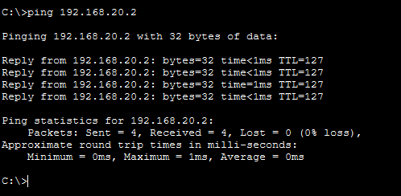

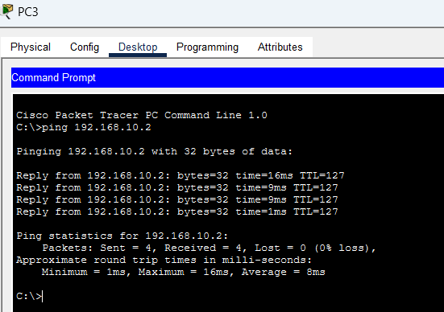

NOW FOR THE NEXT PART OF THE QUE,
STEP 1: Create Management VLAN 99
ON S1,
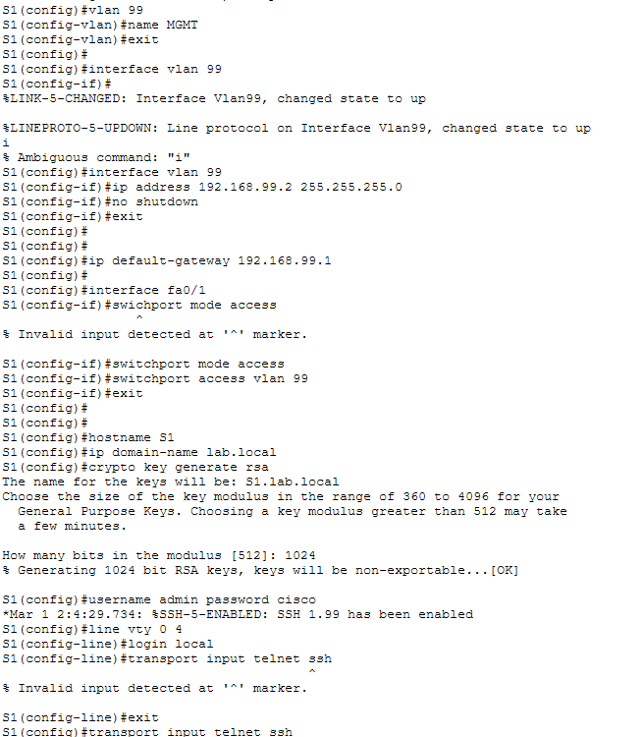

Step 2: ON PC0 CONFIG

IP Address | 192.168.99.10

Subnet Mask | 255.255.255.0

Default Gateway | 192.168.99.1

Step 3: CHECK CONNECTIONS USING PING
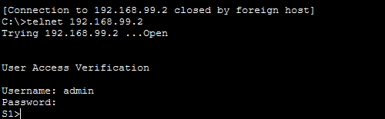

Now we are able to open switch S1 using telnet

QUE5: Using Cisco Packet Tracer, configure a network with:
- 1 Switch (Cisco Catalyst 2960)
- 1 VoIP Phone
- 1 PC connected through the VoIP phone
Perform the following:
- Create Data VLAN and Voice VLAN
- Configure the switch port to support PC + VoIP phon

SOLUTION:

STEP 1: build topology

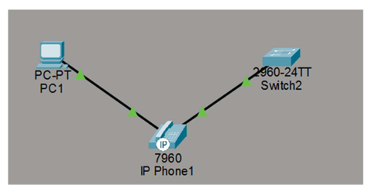

Step 2: switch configuration
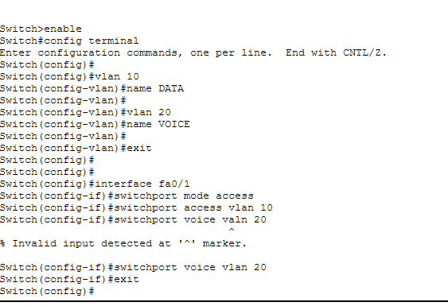

Hence, the adapter to the phone gets created:
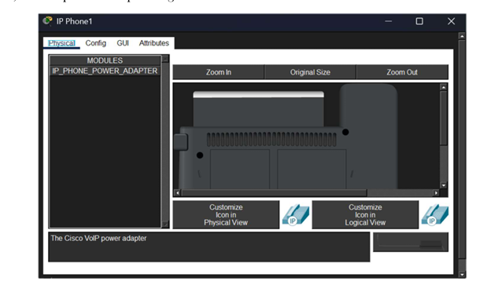
Now, connecting the adapter to the phone:

Hence, the voip phone is powered on and works fine.
Working:

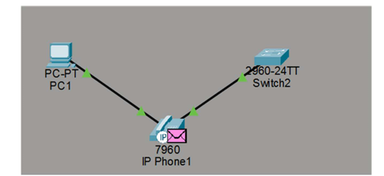

QUE 6: You configured VLANs 10 and 20 on your switch and assigned ports to each VLAN. However, devices in VLAN 10 cannot communicate with devices in VLAN 20. Troubleshoot the issue.

Step – 1: Check If VLAN exists with the command: ‘sh vlan brief’
sh vlan brief

Step – 2: Check IP Configuration
- Devices in VLAN 10 → same subnet
- Devices in VLAN 20 → different subnet
Example:
VLAN | IP Range
10 | 192.168.10.0/24
20 | 192.168.20.0/24

Step – 4: Bring Router in
interface fa0/0.10
encapsulation dot1Q 10
ip address 192.168.10.1 255.255.255.0
interface fa0/0.20
encapsulation dot1Q 20
ip address 192.168.20.1 255.255.255.0

Step – 6: Check Trunk Link
show interfaces trunk
Ensure VLAN 10 & 20 allowed.

Step – 7: Verify Default Gateway
Each device must have:
VLAN | Gateway
10 | 192.168.10.1
20 | 192.168.20

QUE 7: Try Inter VLAN routing with Router
SAME AS THE 4TH QUE INTERN VLAN ROUTING WITH ROUTER.

QUE8: Implement ACLs to restrict traffic based on source and destination ports. Test rules by simulating legitimate and unauthorized traffic.

SOLUTION:

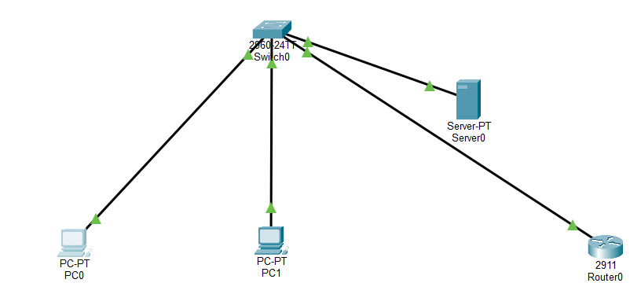

STEP 1: TOPOLOGY CONNECTION
PC0 → S1 | Fa0/1
PC1 → S1 | Fa0/2
Server → S1 | Fa0/3
S1 → R1 | Fa0/24 ↔ G0/0
STEP2: Create VLANs on Switch (S1)
enable
configure terminal
vlan 10
name VLAN10
vlan 20
name VLAN20
exit
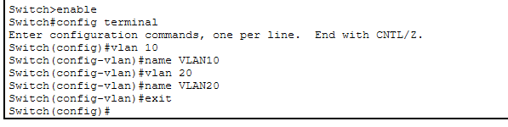

STEP 3: Assign Access Ports

interface fa0/1
switchport mode access
switchport access vlan 10
exit
interface fa0/2
switchport mode access
switchport access vlan 10
exit
interface fa0/3
switchport mode access
switchport access vlan 20
exit
- PC0, PC1 → VLAN 10
- Server → VLAN 20

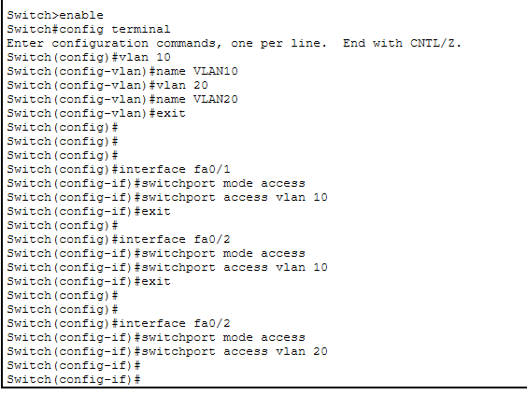
STEP 4: Configure Trunk from Switch to Router

interface fa0/24
switchport mode trunk
exit

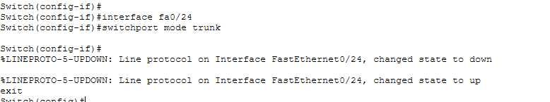

STEP 5: Configure Router-on-a-Stick (R1)
R1 → CLI

enable
configure terminal
interface g0/0
no shutdown
exit
interface g0/0.10
encapsulation dot1Q 10
ip address 192.168.10.1 255.255.255.0
exit
interface g0/0.20
encapsulation dot1Q 20
ip address 192.168.20.1 255.255.255.0
exit

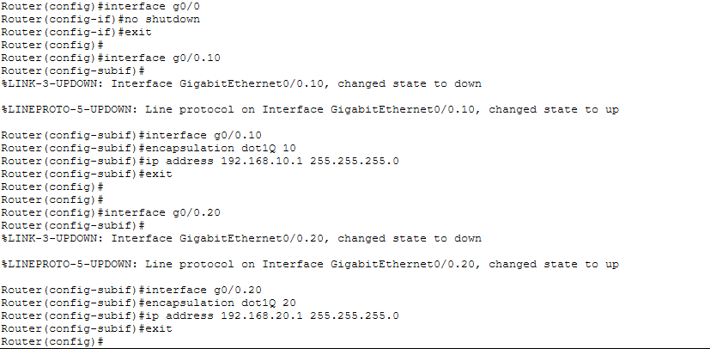

STEP 6: Assign IP Addresses

PC0 / PC1 (VLAN 10)
Desktop → IP Config
Field | Value
IP | 192.168.10.10 / 192.168.10.11
Mask | 255.255.255.0
Gateway | 192.168.10.1
Server (VLAN 20)
Field | Value
IP | 192.168.20.10
Mask | 255.255.255.0
Gateway | 192.168.20.1
STEP 7: Verify Inter-VLAN Works (Before ACL)

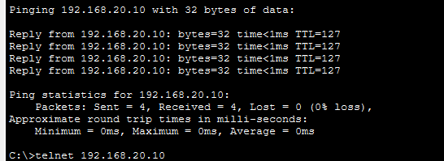
STEP 8: Create Extended ACL on Router
R1 → CLI
ip access-list extended VLAN_FILTER
permit tcp 192.168.10.0 0.0.0.255 192.168.20.0 0.0.0.255 eq 80
deny tcp 192.168.10.0 0.0.0.255 192.168.20.0 0.0.0.255 eq 23
permit ip any any
exit
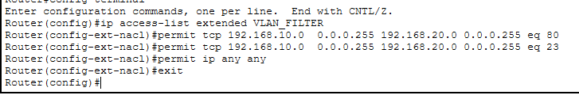

STEP 9: Apply ACL to VLAN 10 Interface (Inbound)

enable
configure terminal
interface g0/0.10
ip access-group VLAN_FILTER in
exit

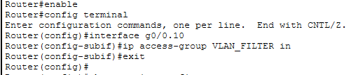

STEP 10: Test After ACL
Test HTTP (Allowed)
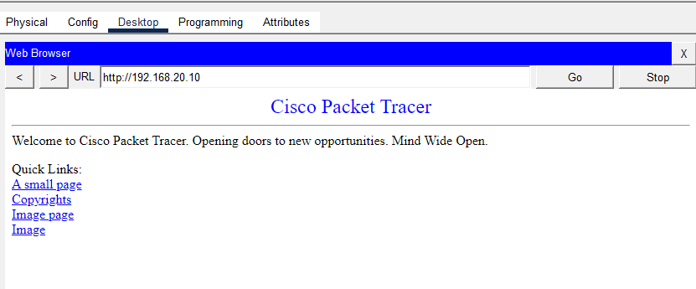

TELNET TEST IS BLOCKED.
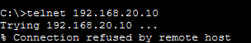

QUE 9: Configure a standard Access Control List (ACL) on a router to permit traffic from a specific IP range.Test connectivity to verify the ACL is working as intended.

SOLUTION:

Configure a standard ACL on a router to permit traffic from a specific IP range and verify connectivity.
Tools/Devices
- Cisco Packet Tracer
- Cisco Catalyst 2960 (S1)
- Cisco 2911 (R1)
- PC0, PC1, Server
Policy
- Permit only 192.168.10.0/24 to reach the Server
- Deny all other sources

Step 1 — Build the Topology
Place devices
- PC0, PC1, Server
- Switch S1
- Router R1
Cable (Copper Straight-Through)
From | Port | To | Port
PC0 | Fa0 | S1 | Fa0/1
PC1 | Fa0 | S1 | Fa0/2
Server | Fa0 | S1 | Fa0/3
S1 | Fa0/24 | R1 | G0/0
Turn on router interface:
enable
configure terminal
interface g0/0
no shutdown
exit
Wait for green lights.

Step 2 — Create VLANs on Switch
S1 → CLI
enable
configure terminal
vlan 10
vlan 20
exit

Step 3 — Assign Ports to VLANs
interface fa0/1
switchport mode access
switchport access vlan 10
exit
interface fa0/2
switchport mode access
switchport access vlan 20
exit
interface fa0/3
switchport mode access
switchport access vlan 20
exit
- PC0 → VLAN 10
- PC1, Server → VLAN 20

Step 4 — Trunk Switch to Router
interface fa0/24
switchport mode trunk
exit

Step 5 — Configure Router-on-a-Stick
R1 → CLI
enable
configure terminal
interface g0/0.10
encapsulation dot1Q 10
ip address 192.168.10.1 255.255.255.0
exit
interface g0/0.20
encapsulation dot1Q 20
ip address 192.168.20.1 255.255.255.0
exit

Step 6 — Assign IP Addresses
PC0 (VLAN 10)
- IP: 192.168.10.10
- Mask: 255.255.255.0
- Gateway: 192.168.10.1
PC1 (VLAN 20)
- IP: 192.168.20.10
- Mask: 255.255.255.0
- Gateway: 192.168.20.1
Server (VLAN 20)
- IP: 192.168.20.20
- Mask: 255.255.255.0
- Gateway: 192.168.20.1

Step 7 — Verify Connectivity (Before ACL)
From PC0:
ping 192.168.20.20
It should work.
From PC1:
ping 192.168.20.20

Step 8 — Create Standard ACL (on Router)
We permit only VLAN 10 network.
ip access-list standard PERMIT_VLAN10
permit 192.168.10.0 0.0.0.255
deny any
exit

Step 9 — Apply ACL to VLAN 20 Interface (Inbound)
Standard ACL filters only by source, so apply it near destination.
interface g0/0.20
ip access-group PERMIT_VLAN10 in
exit

Step 10 — Testing After ACL
From PC0 (VLAN 10)
ping 192.168.20.20
Works (permitted source).
From PC1 (VLAN 20)
ping 192.168.20.20
Fails (denied source).

QUE 10: Create an extended ACL to block specific applications, such as HTTP or FTP traffic. Test the ACL rules by attempting to access blocked services.

SOLUTION:

Step 1 — Create the Topology
Place devices
- PC0
- Server
- Switch S1
- Router R1
Cable (Copper Straight-Through)
From | Port | To | Port
PC0 | Fa0 | S1 | Fa0/1
Server | Fa0 | S1 | Fa0/2
S1 | Fa0/24 | R1 | G0/0
Turn on router interface:
enable
configure terminal
interface g0/0
no shutdown
exit
Wait for green lights.

Step 2 — Create VLANs on Switch
S1 → CLI
enable
configure terminal
vlan 10
vlan 20
exit

Step 3 — Assign Ports
interface fa0/1
switchport mode access
switchport access vlan 10
exit
interface fa0/2
switchport mode access
switchport access vlan 20
exit

Step 4 — Configure Trunk to Router
interface fa0/24
switchport mode trunk
exit

Step 5 — Router-on-a-Stick Configuration
R1 → CLI
enable
configure terminal
interface g0/0.10
encapsulation dot1Q 10
ip address 192.168.10.1 255.255.255.0
exit
interface g0/0.20
encapsulation dot1Q 20
ip address 192.168.20.1 255.255.255.0
exit

Step 6 — Assign IP Addresses
PC0 (VLAN 10)
- IP: 192.168.10.10
- Mask: 255.255.255.0
- Gateway: 192.168.10.1
Server (VLAN 20)
- IP: 192.168.20.10
- Mask: 255.255.255.0
- Gateway: 192.168.20.1
On Server → Services
- Turn HTTP ON
- Turn FTP ON

Step 7 — Verify Before ACL
From PC:
ping 192.168.20.10
Open Web Browser → http://192.168.20.10 → Works
FTP → Works

Step 8 — Create Extended ACL on Router
ip access-list extended BLOCK_APPS
deny tcp 192.168.10.0 0.0.0.255 192.168.20.0 0.0.0.255 eq 80
deny tcp 192.168.10.0 0.0.0.255 192.168.20.0 0.0.0.255 eq 21
permit ip any any
exit

Step 9 — Apply ACL to VLAN 10 Interface (Inbound)
interface g0/0.10
ip access-group BLOCK_APPS in
exit

Step 10 — Testing After ACL
Test HTTP (Blocked)
PC → Browser → http://192.168.20.10 → Fails
Test FTP (Blocked)
FTP to server → Fails
Test Ping (Allowed)
ping 192.168.20.10

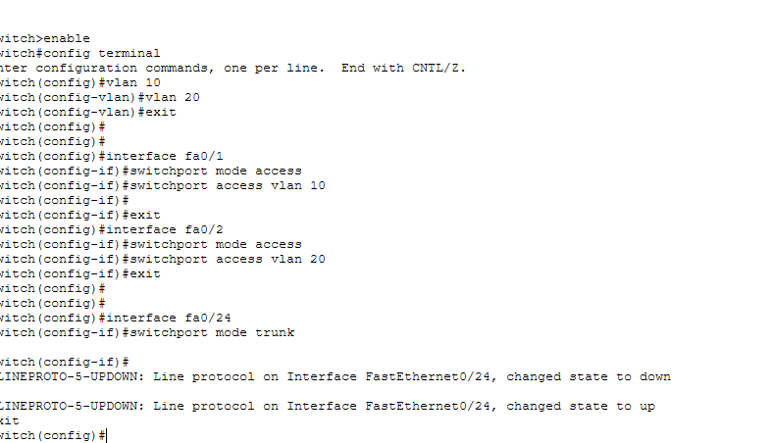

STEP 5:
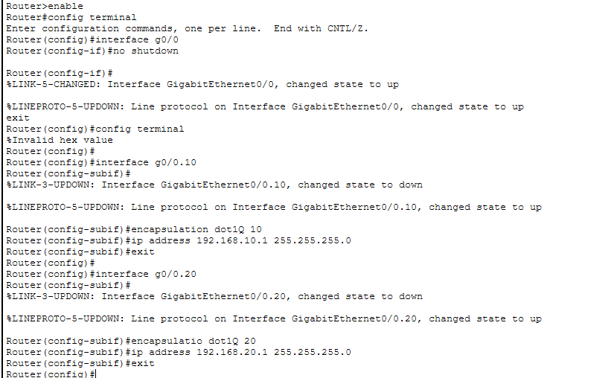
STEP 6: IP CONFIG IN PC AND SERVER!
STEP 7: PINGING AND CHECKING CONNECTIVITY
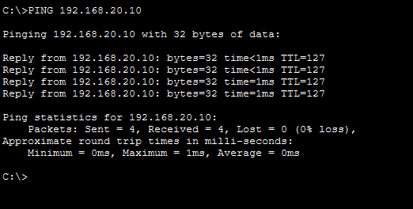

STEP 8: CREATE EXTENDED ACL ON ROUTER

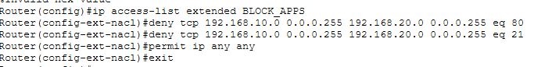

STEP 9: Apply ACL to VLAN 10 Interface (Inbound)
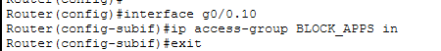

STEP 10: Testing After ACL
FOR HTTP,
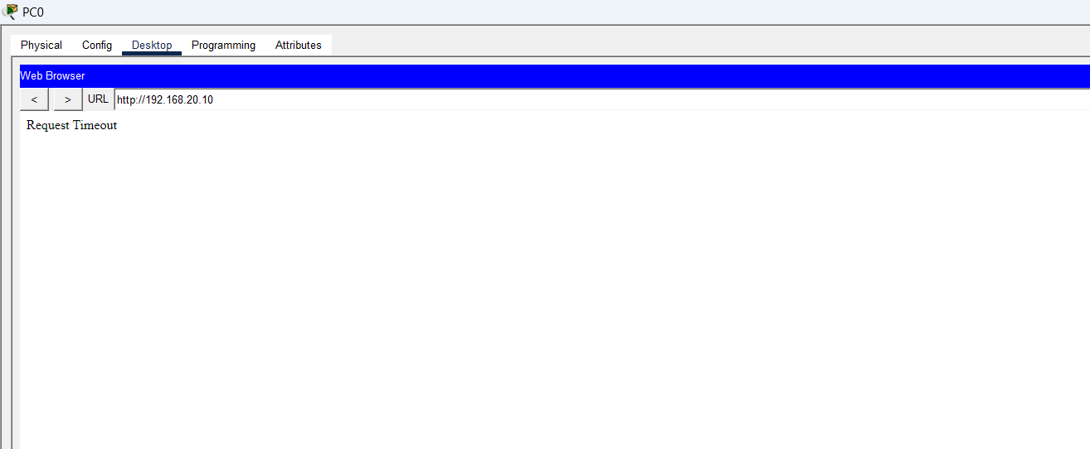

FOR FTP,
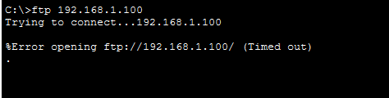

TEST PING IS ALLOWED
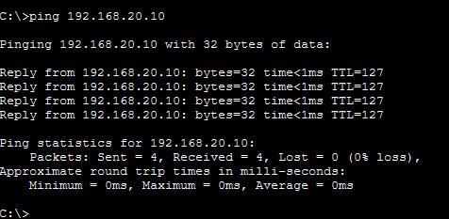

QUE 11: Try Static NAT, Dynamic NAT and PAT to translate Ips
SOLUTION:

Step 1 — Create the Topology
Devices:
- 1 Router (e.g., Cisco Systems 2811 in Packet Tracer)
- 1 Switch
- 3 PCs (PC0, PC1, PC2)
- 1 Server (acts as Internet server)
Connections:
- PCs → Switch → Router (inside)
- Router → Server (outside)

🌐 Step 2 — IP Addressing Plan
Inside Network (LAN)
Device | IP | Subnet | Gateway
PC0 | 192.168.1.10 | 255.255.255.0 | 192.168.1.1
PC1 | 192.168.1.20 | 255.255.255.0 | 192.168.1.1
PC2 | 192.168.1.30 | 255.255.255.0 | 192.168.1.1
Outside Network (Public side)
Device | IP | Subnet
Server | 200.0.0.2 | 255.255.255.0
Router (outside) | 200.0.0.1 | 255.255.255.0

🔧 Step 3 — Configure Router Interfaces
enable
conf t
int fa0/0
ip address 192.168.1.1 255.255.255.0
no shutdown
int fa0/1
ip address 200.0.0.1 255.255.255.0
no shutdown

🏷️ Step 4 — Mark NAT Inside and Outside
int fa0/0
ip nat inside
int fa0/1
ip nat outside

— Static NAT (One-to-One Mapping)
Map PC0 to a fixed public IP.
ip nat inside source static 192.168.1.10 200.0.0.10
Test
From PC0:
ping 200.0.0.2
Check:
show ip nat translations
You will see permanent mapping.

— Dynamic NAT (Pool of Public IPs)
Create a pool of public IPs for PCs.
access-list 1 permit 192.168.1.0 0.0.0.255
ip nat pool MYPOOL 200.0.0.20 200.0.0.25 netmask 255.255.255.0
ip nat inside source list 1 pool MYPOOL
Test
From PC1 and PC2:
ping 200.0.0.2
Check:
show ip nat translations
They will get any IP from the pool.

PAT (NAT Overload)
Many PCs share one public IP using port numbers.
First remove dynamic NAT:
no ip nat inside source list 1 pool MYPOOL
Now configure PAT:
ip nat inside source list 1 interface fa0/1 overload
Test
From PC1 and PC2:
ping 200.0.0.2
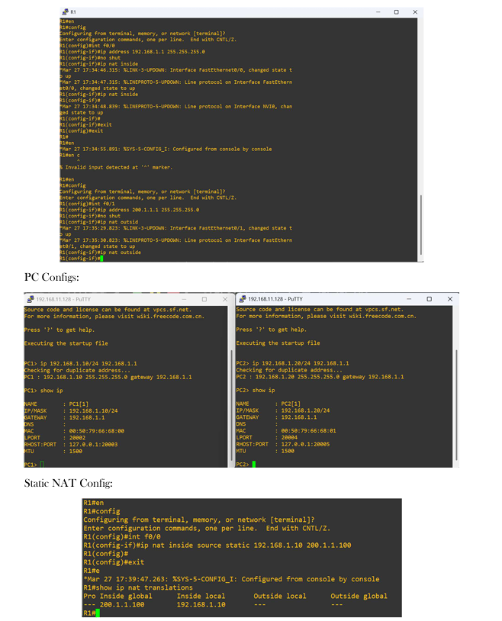

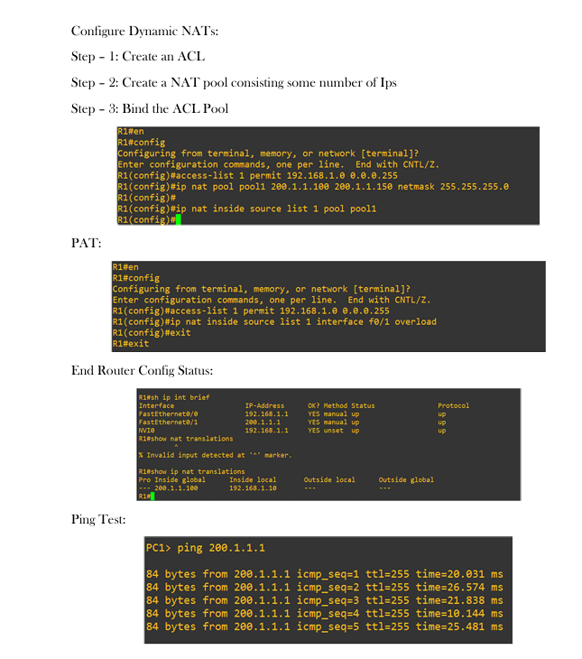

que 12:
Download iperf in laptop/phone and make sure they are in same network. Try different iperf commands with tcp, udp, birectional, reverse, multicast, parallel.
SOLUTION:

SERVER SIDE:
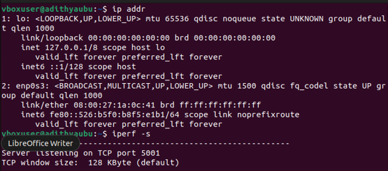
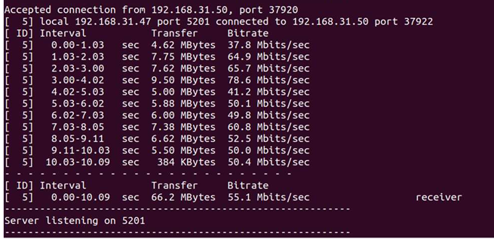

CLIENT SIDE:
